containment

You awaken dazed and confused. As you recover your senses you realise you are locked in the lab where you work and it is dark. The last thing you remember was performing some tests on your companies latest breakthrough, the world’s first sentient AI.

Team Lightning

Table of Contents

Game Overview 4

Concept# 4

Themes# 4

Features# 4

Genre# 4

Setting# 4

Target Audience# 4

Game Flow Summary# 4

Aesthetics# 5

Gameplay and Mechanics 6

Gameplay 6

Game progression# 6

Mission/challenge structure 6

Puzzle structure 6

Objectives# 6

Play Flow# 6

Mechanics 7

Physics# 8

Movement in Game# 8

Objects# 8

Crafting 8

Actions 8

Screen Flow# 9

Game Options# 9

Replaying and Saving# 9

Story, Setting and Characters 11

Story and Narrative# 11

Game World 11

General look and feel if the world# 11

Areas 11

Characters 11

Maps 13

Room one 13

Interface 14

Visual System 14

Main Menu# 14

HUD/In Game# 14

Pause Menu# 15

Inventory# 16

Crafting# 16

Control System 17

Main Menu# 17

Main Game# 17

Pause Menu# 17

Inventory# 17

Crafting# 17

Audio, music, sound effects 17

Technical 18

Class Diagrams 18

Game 18

GameObject 18

Item 18

Target Hardware 18

Min specs 18

Recommended specs 19

Dev Hardware 19

Min Specs 19

Software# 19

Game Engine# 19

Network Requirements# 19

Localisation# 19

Game Art 20

Inspiration 20

Assets 21

# Game Overview

## Concept#

You are trapped in a facility locked in by an AI. The power has been cut and you must find a way to escape. Will you discover the true reason FIBPI1597 escaped on your way?

## Themes#

* Exploration
* AI
* Escape

## Features#

* Puzzle solving
* Crafting
* Multiple Escape Routes
* Story

## Genre#

2D top down adventure

## Setting#

Near Future, Sci-Fi, Laboratory/Robotic facility.

## Target Audience#

The target audience for this type of game is quite broad with Puzzle games appealing to a broad spectrum of players with a 42/58% split between the gender of players who play casual puzzle games(Statista, 2018). The Near future Sci-fi Setting setting is proven to appeal to a wide audience, typically older males, but not exclusively. The game should appeal to the Retro gamer, which as it will feature 8 bit graphics and have a retro feel.

## Game Flow Summary#

The player will move through the facility discovering clues about the AI and trying to escape by solving puzzles to progress through the facility and eventually escape.

## Aesthetics#

The game will feature a retro graphic style and the game world will be viewed in 2d from a top down viewport. Below are some examples from other games:

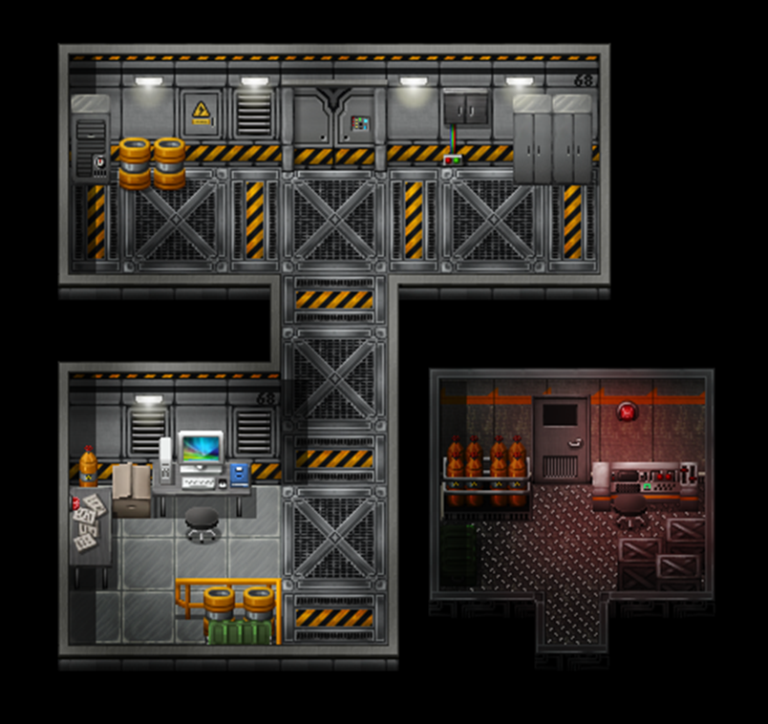

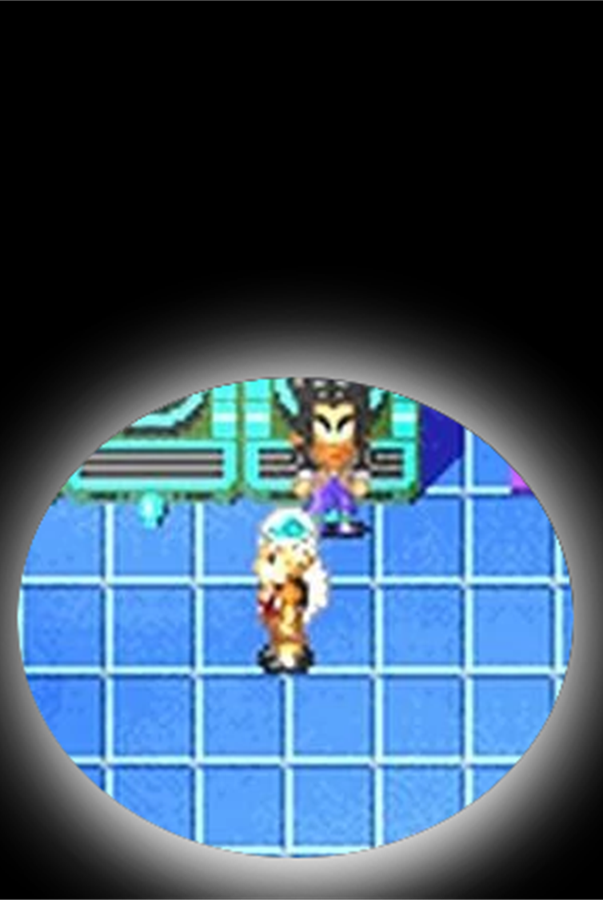

# Gameplay and Mechanics

## Gameplay

### Game progression#

The facility will have multiple routes through which the player can travel. To progress in certain areas the player will have to solve a puzzle in order to open a door or move something blocking a path. The game will also feature clues scattered around the facility that can be gathered and will be counted towards which ending the player will see when they escape the facility.

### Mission/challenge structure

### Puzzle structure

The puzzles will

### Objectives#

The main objective of the game is to escape the facility. The secondary objective is to discover all the clues about what reason 1597 had to escape. A third objective is to complete all the puzzles in the game.

### Play Flow#

As shown in the flow diagram below the player will enter a new room and then search it for items and clues. If the room has a puzzle the player must solve it to progress through the facility. The puzzle may require the use of items or crafting which the player may not possess in which case the player must keep exploring the facility in order to find what they need to complete the puzzle.

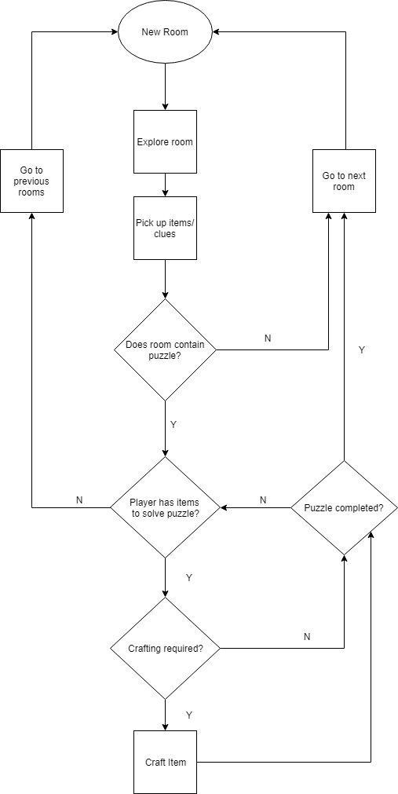

## Mechanics

What are the rules to the game, both implicit and explicit. This is the model of the universe that the game works under. Think of it as a simulation of a world, how do all the pieces interact? This actually can be a very large section.

### Physics#

The game world is 2d top down so there will only be 2d physics and the only moving objects will be the player, who will be constrained to movement on a 2d plane and will not be able to collide with objects such as doors, walls and furniture, and some items such as a movable crate which will be pushed by the player again confined to a 2d plane and unable to collide or move through objects such as walls, doors and furniture.

### Movement in Game#

The player will be able to move on the x and y axis of the game world by using the WASD keys. The game will be 2d top down and so these will be the only dimensions in the game. The player will not be able to jump. The game world will be divided into a grid in which the player can move one space at a time.

### Objects#

The player can pick up an object by pressing the space bar when the player is next to the object. The player must be in a grid cell next to the object in order to be able to pick it up. The player will have limited space in their inventory and so if it is full they must first drop an object in their inventory in order to free up some space. To drop an object the player must open the inventory menu and then select the item to drop by clicking on it or using the arrow keys to highlight the item they wish to drop and then pressing the D key.

### Crafting

### Actions

, including whatever switches and buttons are used, interacting with objects, and what means of communication are used

### Screen Flow#

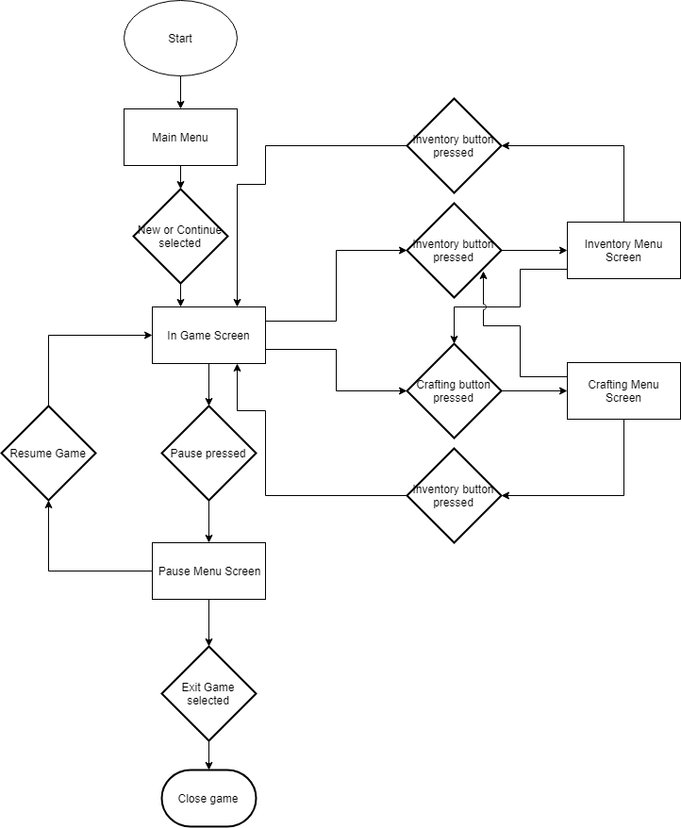

## Game Options#

There will be no game options for the player such as difficulty, key binding or graphics settings.

## Replaying and Saving#

The game will feature several different ways for the player to escape allowing for replay ability.

The player will be able to save the game via the pause menu in game. The player can choose to load a game from the main menu. There will be one save file for the game.

# Story, Setting and Characters

## Story and Narrative#

The game is set in an empty lab facility where the player has been locked in by an escaped AI called 1597. The player is locked in and must find a way to escape the facility. Before 1597 left they powered down the facility leaving the player in the dark. The player can take various routes through the facility to escape and will discover clues as to what reason 1597 had to leave the facility for and how 1597 originated. The facility is fully automated and completely run on, and managed by technology. The player character is the only person working in the facility as anyone else working on the project does so remotely.

The clues will all feature patterns as the AI’s origins was developed from an AI program designed to find and analyse patterns in various forms. One clue might be for example a stock market report on company which would have a pattern that matches the pattern of another clue that was a report into murders in a certain location. These would make the player think that possibly the AI was motivated to get money and maybe go on a killing spree but the real reason the AI was looking at these reports was because of the matching pattern. These clues would be found on terminals scattered around the facility meaning that they may not all be found. The Player will also encounter some of the predecessors of 1597 that will give more obvious clues that the underlying AI program is obsessed with finding new Patterns and that having become bored with what the facility had to offer had decided to escape.

When the player finally escapes the facility, they will get one of three endings. If all clues were found and the player found all of 1597’s predecessors, then the player will find the AI in a field staring at some birds in flight. The player character will then join 1597 and the game will fade out. If the player found only some of the clues, then the player same scene will occur, but the player will be hostile to 1597 and destroy them. If the player found 3 or less clues, then the ending will feature the player character making their escape but show nothing about what happened to 1597.

## Game World

### General look and feel if the world#

The game is set in the near future in a lab facility and so the game world will feature different rooms that have different purposes that would be required in the production of robotics and AI programming / testing. The power has been cut and as such the whole lab will be dimly lit with emergency lighting, or not lit at all requiring the player to use a torch to be able to see which would also only cast a dim light. The facility would be in good repair otherwise with clean surfaces and lots of glass and metal materials as well as various consoles and servers around.

### Areas

including the general description and physical characteristics as well as how it relates to the rest of the world (what levels use it, how it connects to other areas)

## Characters

#### The Player#

The player character is a scientist hired to perform a Turing test on 1597. They have been flown to a top-secret facility and have been working with 1597 for several weeks before the escape.

#### 1597

#### 987

#### 610

#### 377

#### 233

#### 144

# Maps

## Room one

# Interface

## Visual System

### Main Menu#

As shown below the main menu will feature the games name prominently along the top. There will be three options available to the player. The first will be highlighted to show it is the currently selected option and will be used to start a new game. the second and third option will be greyed out to show that they are not selected. The second option will be to continue the current save and will only be available if a save game file is available. The third option will be to exit the game. the main menu will also display a random gameplay tip to remind players of controls and what to look for in game.

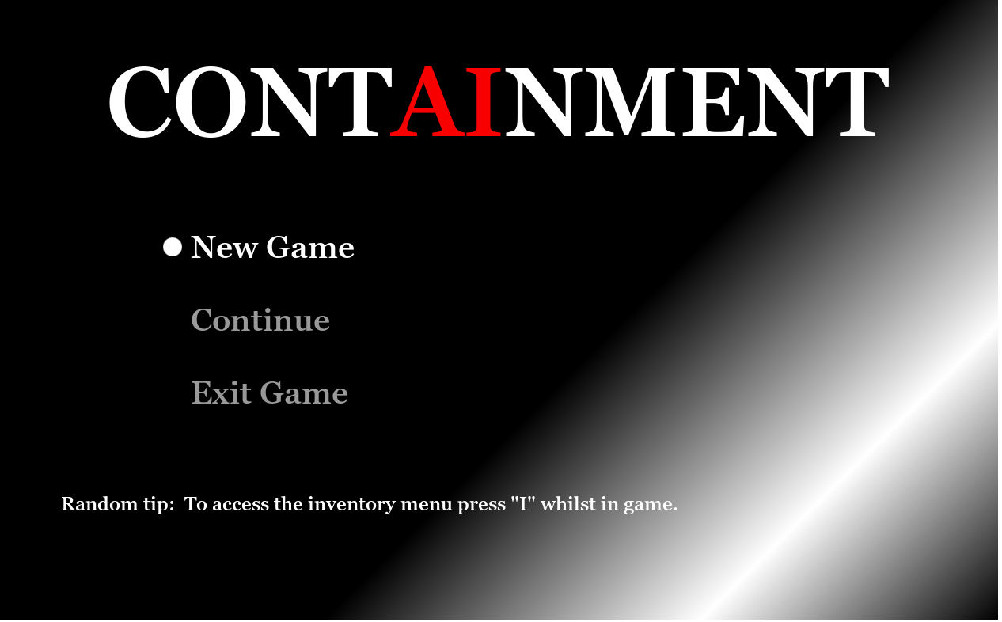

### HUD/In Game#

There will be no in game HUD as the player explores the map. As shown below the only interface other than for the pause, inventory and crafting menus will be a text display which will appear along the bottom of the screen to provide feedback when the player picks up an item, drops an item, crafts an item, interacts with a game object or one of the clues.

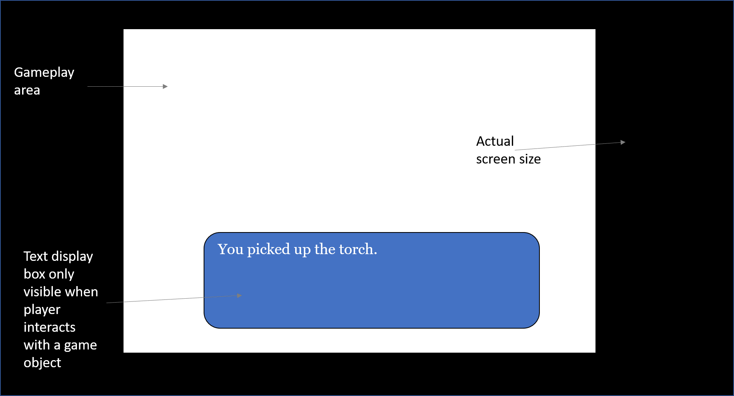

### Pause Menu#

When the pause menu is displayed the game screen will still be visible but will be overlaid with a transparent grey texture as shown below. The menu will contain three options with the currently selected option highlighted with a dot to the left and be coloured white. The remaining two options will be greyed out to show they are not selected.

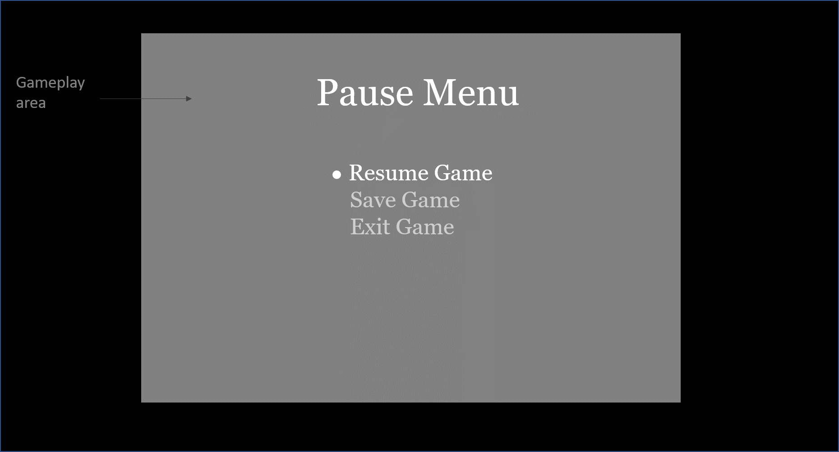

### Inventory#

As shown below the inventory menu will be overlaid over the main game screen with the player shown all available slots.

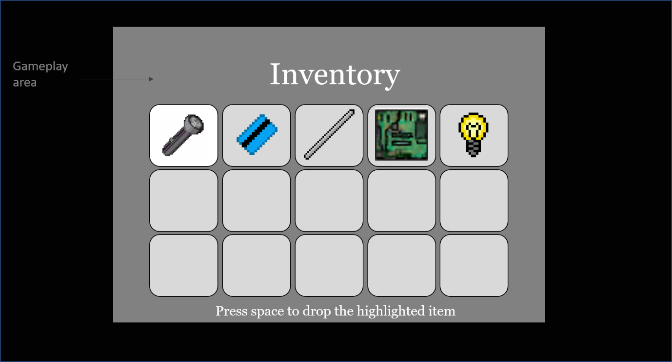

### Crafting#

As shown below the crafting menu will be overlaid over the main game screen

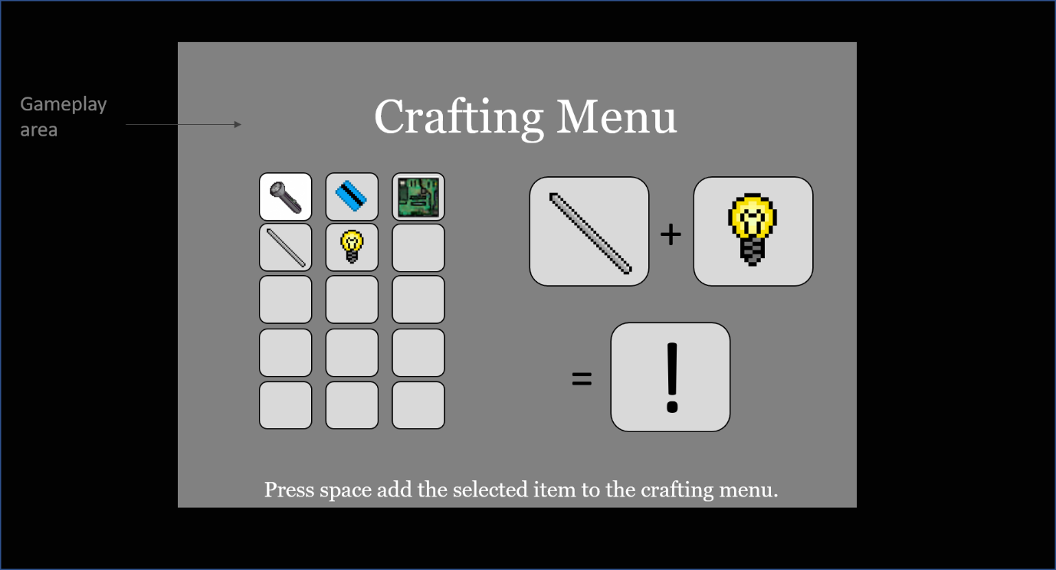

## Control System

### Main Menu#

The main menu will have 3 options for the player to choose from. Option 1 will be a new game, option 2 will be continue and will only be selectable if a save is available, and option 3 which will be exit.

### Main Game#

In the main game the player will be able to move through the current map by using the WASD keys to move up, left, down and right. The player can interact with objects by pressing the space bar. This will bring up a text window that will communicate to the player what the outcome is of the interaction such as an item is picked up or a button is pressed. The player can bring up the Pause menu at any time by pressing the P button on the keyboard. The player can open th Inventory and Crafting menus by pressing I and C respectively.

### Pause Menu#

The pause menu will have three options and will be accessible in game by pressing P t0 pause the game. Option 1 will be to return to the game, option 2 will be to save the game and option 3 will be to exit the game.

### Inventory#

The inventory menu will be accessible by pressing the I key and will pause the game in the background whilst the player looks through their inventory. Items in the inventory will be selectable with the mouse by clicking on an inventory slot or by using the WASD keys to highlight the inventory item that the player wishes to select. The player will have the option to drop the item by pressing space bar. To exit the inventory menu the player can again press I to toggle the menu off or press C to access the Crafting menu.

### Crafting#

To access the crafting menu in game the player must press the C key which will pause the game in the background and open the crafting menu. The player’s inventory will be on the left-hand side of the screen and there will be two slots on the right to represent the two items to combine. A third slot will display the outcome. To select an item from the inventory the player can use the mouse to click on the item which will then show in the first available slot of the two available for crafting. The player can also select an item by using the WASD keys to highlight the inventory item that the player wishes to select and then press the space bar to select in the first available slot. If both slots are full the selected item will not appear in either of the two full slots and an item must be removed from one of these slots before a new item can be added to one of them. To remove an item from one of the two available crafting slots the player can either click on the item slot or highlight and remove it from position by using the WASD keys to highlight and then pressing the space bar to remove it. If the two selected items are able to combine to craft a new item, the new item will appear in the third slot on the right-hand side of the screen otherwise it will display an exclamation mark representing that the items do not combine. To select a new item the player can click on the new item which will add the new item to the players inventory and remove the two items used to craft it from both the players inventory and the two slots used to craft an item and make the third slot blank as well. The player can also select the item by using the WASD keys to highlight the new item and then pressing the space bar to craft it.

## Audio, music, sound effects

If we’re lucky

# Technical

## Class Diagrams

### Game

### GameObject#

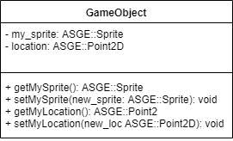

### Item#

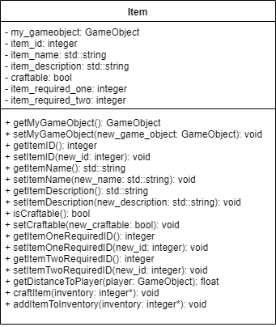

### Clue#

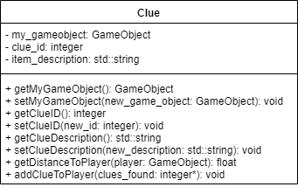

### Room#

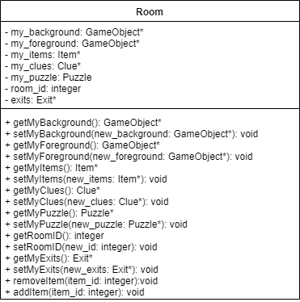

### Puzzle#

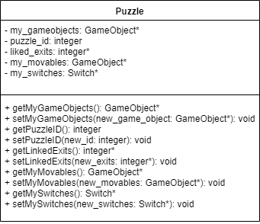

### Switch#

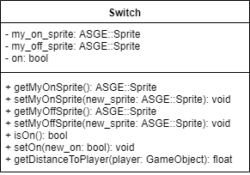

### Exit#

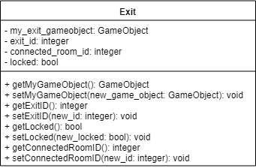

### Player#

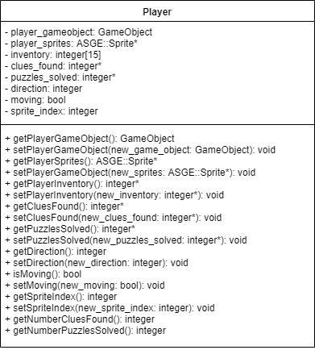

## Target Hardware

### Min specs

### Recommended specs

## Dev Hardware

### Min Specs

### Software#

JetBrains C-Lion 2018.1, C-Make, MinGW, Windows 10.

### Game Engine#

We will be using the ASGE as our game engine for this project.

## Network Requirements#

None

## Localisation#

The game will not be localised in any other language. The game will work on OSX, Windows and Linux operating Systems.

# Game Art

## Inspiration

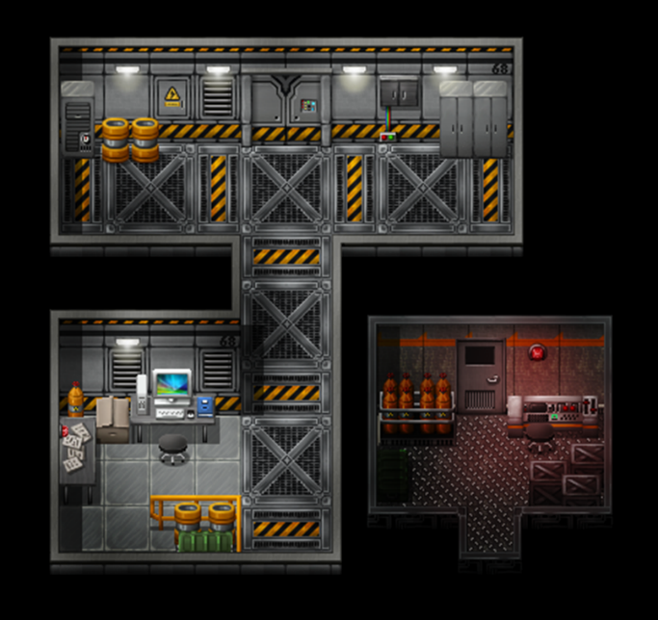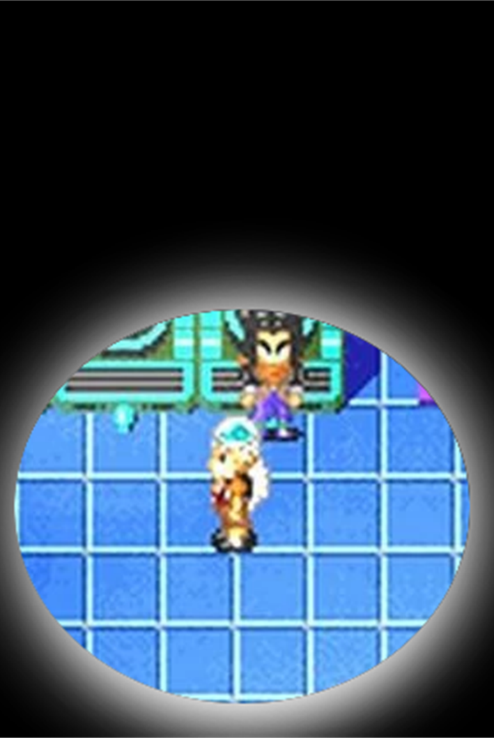

Assets

